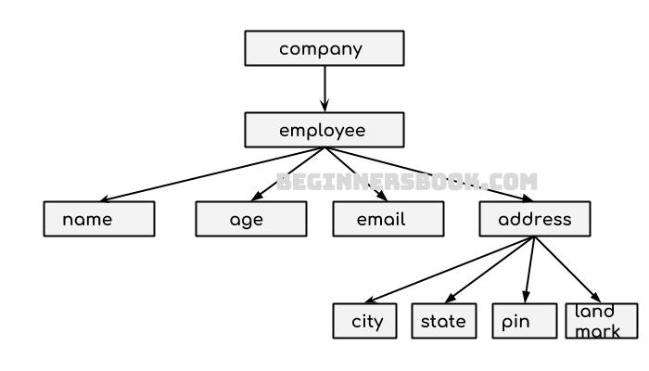
XML document(well formed document)
==========-------=======================
<company>
<employee>
<name>Arun</name>
<age>19</age>
<email>as@yahoo.com</email>
<address>
<city>Agra</city>
<state>Up</state>
<pin>281001</pin>
<landmark>temple </landmark>
</address>
</employee>
<employee>
<name>VArun</name>
<age>22</age>
<email>ak@yahoo.com</email>
<address>
<city>Agra</city>
<state>Up</state>
<pin>281001</pin>
<landmark>temple </landmark>
</address>
</employee>
</company>

===========================
Valid document with DTD
==========================
K.dtd
<!ELEMENT company(employee)>
<!ELEMENT employee(name,age,email,address)>
<!ELEMENT address(city,state,pin,landmark)>
<!ELEMENT name(#PCDATA)>
<!ELEMENT age(#PCDATA)>
<!ELEMENT email(#PCDATA)>
<!ELEMENT city(#PCDATA)>
<!ELEMENT state(#PCDATA)>
<!ELEMENT pin(#PCDATA)>
<!ELEMENT landmark(#PCDATA)>

abc.xml
=========
<?xml version="1.0" ?>
<!-- xml doc -->
<!DOCTYPE company SYSTEM "k.dtd" >
<company>
<employee>
<name>Arun</name>
<age>19</age>
<email>as@yahoo.com</email>
<address>
<city>Agra</city>
<state>Up</state>
<pin>281001</pin>
<landmark>temple </landmark>
</address>
</employee>
<employee>
<name>VArun</name>
<age>22</age>
<email>ak@yahoo.com</email>
<address>
<city>Agra</city>
<state>Up</state>
<pin>281001</pin>
<landmark>temple </landmark>
</address>
</employee>
</company>
-----------------------
Internal DTD
-----
abc.xml
-----
<?xml version="1.0" ?>
<!-- xml doc -->
<!DOCTYPE company
[
<!ELEMENT company(employee)>
<!ELEMENT employee(name,age,email,address)>
<!ELEMENT address(city,state,pin,landmark)>
<!ELEMENT name(#PCDATA)>
<!ELEMENT age(#PCDATA)>
<!ELEMENT email(#PCDATA)>
<!ELEMENT city(#PCDATA)>
<!ELEMENT state(#PCDATA)>
<!ELEMENT pin(#PCDATA)>
<!ELEMENT landmark(#PCDATA)>
]>
<company>
<employee>
<name>Arun</name>
<age>19</age>
<email>as@yahoo.com</email>
<address>
<city>Agra</city>
<state>Up</state>
<pin>281001</pin>
<landmark>temple </landmark>
</address>
</employee>
<employee>
<name>VArun</name>
<age>22</age>
<email>ak@yahoo.com</email>
<address>
<city>Agra</city>
<state>Up</state>
<pin>281001</pin>
<landmark>temple </landmark>
</address>
</employee>
</company>
-----------------

